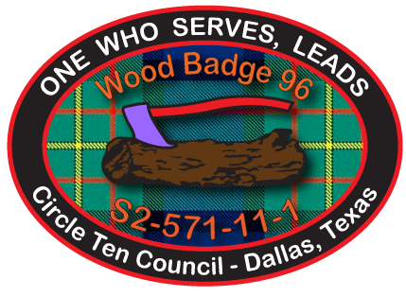

Wood Badge 96 Coursewear Order and Size Form
Each person will receive 1 hat, 2 pocket patches and 1 short-sleeved course activity shirt as part of their course fee. You may purchase additional shirts, hats and fleece jackets. Purchase of additional items is strictly optional.

Please complete this form even if you are not ordering any additional items so we will have enough of each shirt size on hand.

You may use the “Tab” Key to Navigate between fields on this form.
Name: |  | Date:
Address: |  | Phone:

Adult Male T-Shirt Size (check one): Small Medium Large XLarge 2XLarge 3XLarge

Qty | Description | Unit Price | Amount
1 | WB96 Activity short-sleeve t-shirt (Please indicate size above) | $0.00 | Included
 | Additional short-sleeve activity t-shirt (small, medium, large, extra-large) | $12.00
 | Additional short-sleeve activity t-shirts (size 2XL, 3XL) | $14.00
 | Long-sleeve activity t-shirts (small, medium, large, extra-large) | $14.00
 | Long-sleeve activity t-shirts (sizes 2XL, 3XL) | $16.00
1 | WB96 Course Ball-Cap Hat | $0.00 | Included
 | Additional WB96 Course Ball-Cap Hat | $10.00
 | Optional WB96 Custom Polar Tec Fleece Jacket | $36.00
Total Due (Please make check payable to Circle Ten Council, BSA) ➔

Please e-mail (forms@wb96.org) in your order form as soon as possible and
submit your check so it is received no later than December 11, 2010.

Checks may be submitted at the December 11, 2010 orientation or mailed to:

Leigh Anne LeBlanc, ASM-FAC
5709 River Rock Ln.
Plano, TX 75093

Staff use only
Amount received: $ Check no: Cash (circle if cash received)
By: Date:

