W O O D B A D G E F O R T H E 2 1 S T C E N T U R Y
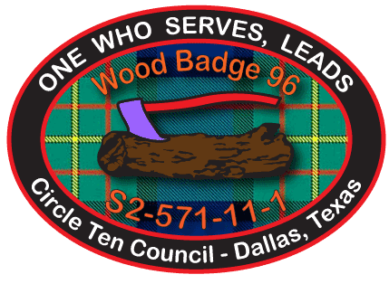
Application for
Training Recognition
Wood Badge 96

Name:

E-mail Address:
City, State, Zip:
Telephone (C): (H):

District: Unit No.

Scouting Position:

Council Name and Number: CIRCLE TEN – 571 Course No. S2-571-11-1
Location: Collin County Adventure Camp Date: January 28-30 & February 18-20, 2011

Certificate No. Wood Badge Patrol:

Course Director: Ramsay Ellis

Date:

Part 2: To participant's Council leadership training chair:
This Wood Badge participant has completed the practical application phase of the course. I attest that the Wood Badge ticket has also been completed and recommend that the participant be awarded Wood Badge recognition.
Certified by Troop Guide:
Date:

Part 3: Scheduling information for the Recognition Ceremony:
Day: Date: Time:
Location:
Address:
Notes:

