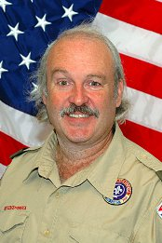
Beading Ceremony
Come join the celebration and show your support!
For : John P. Hall III
Patrol : Antelope
Troop Guide : Harold Young
When : Saturday, February 4, 2012
Time : 5:30pm (doors open)
Where : Cub World Activity Center
Camp Wisdom
6400 W. Red Bird Ln.
Dallas, TX 75236

